# Title: On “Служба ветеринарної допомоги” page. When scrolling down, we see inappropriate placement of a text inside a squared border.

**Priority:** High

**Severity:** S4 Minor

**Environment:**Samsung Galaxy J7 Neo (720x1280 pixels, Android 9 OS)

**Steps to reproduce**

1. Open the Main page: [https://kmlvm.kyivcity.gov.ua](https://kmlvm.kyivcity.gov.ua/)

2. Scroll down and tap on the square named “Служба ветеринарної допомоги”.

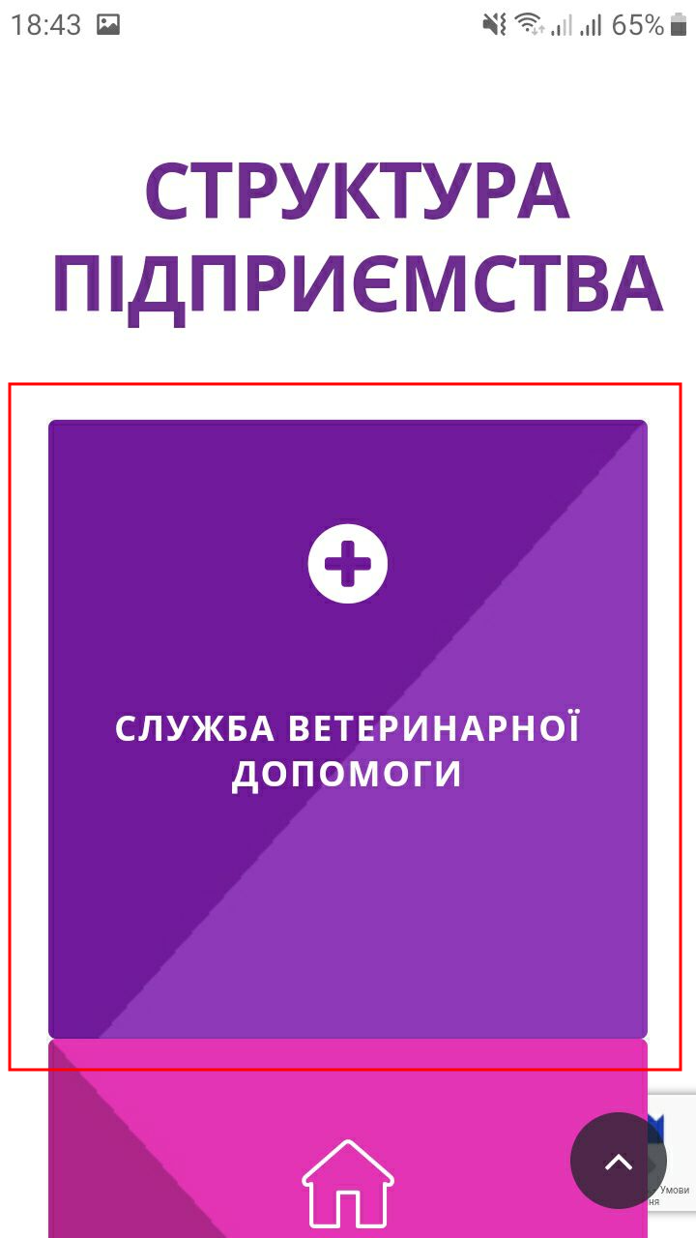

3. On a flipped image tap “Детальніше” button.

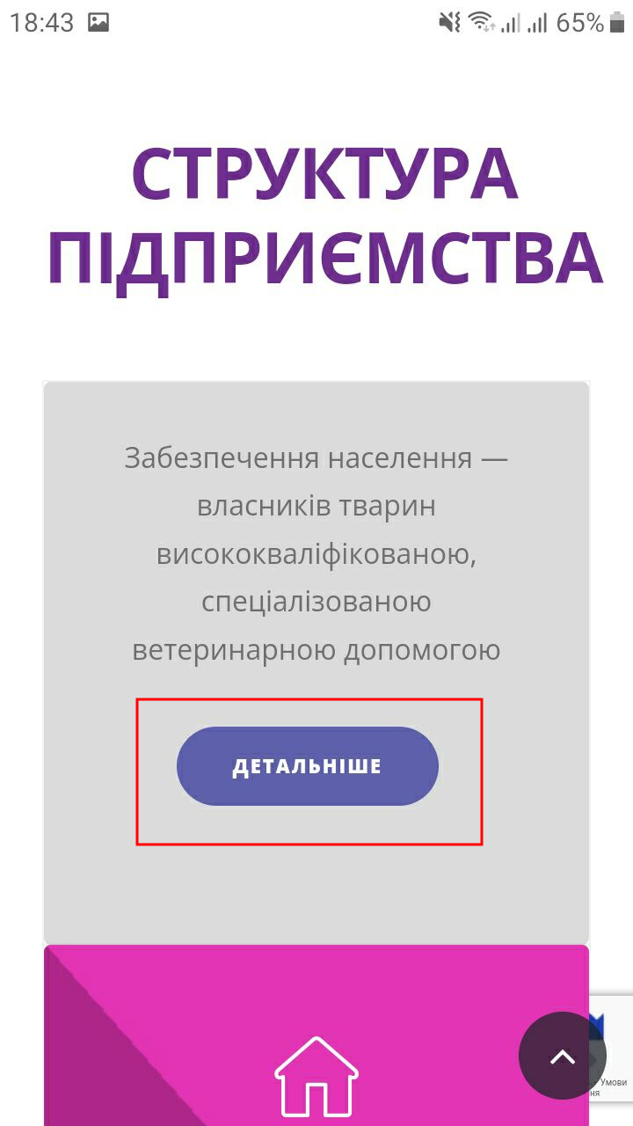

4. On an opened page “Служба ветеринарної допомоги” scroll down to the section called “Структурні підрозділи”.

**Actual result**

We see inappropriate placement of a text inside a squared border in this “Структурні підрозділи” section. We see many letters outside the border.

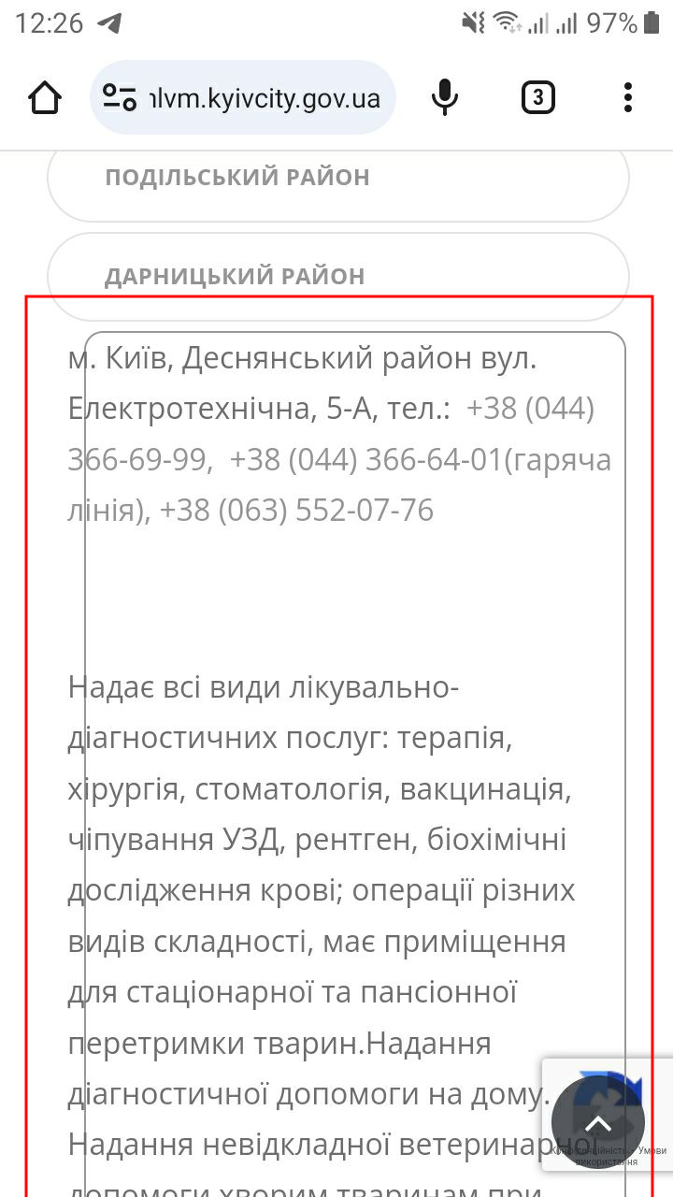

**Expected result**

The text must be placed exactly inside this squared border (not outside).

*Screenshot from* ***Jira****:*

